Gather your findings in the table below. As a class, we will use the distance and speed to confirm the expansion of the universe.

Part A: Determine the luminosity of a cepheid using their pulsation period
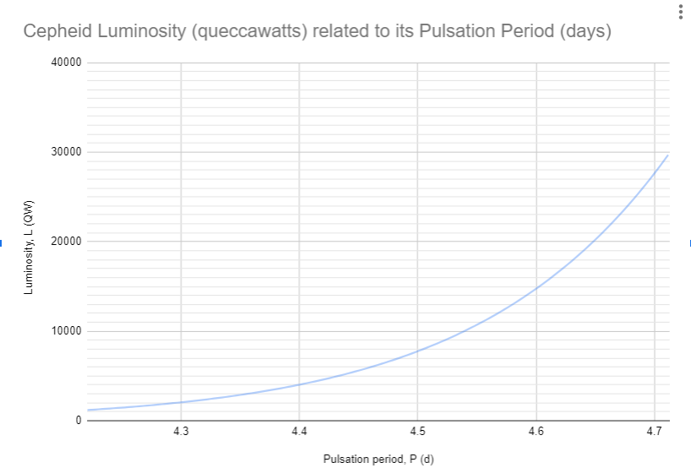

Group | Pulsation Period, P (days) | Luminosity, L (QW)
A | 4.3
B | 4.4
C | 4.5
D | 4.6
E | 4.7

Part B: Calculating the cepheid’s distance using luminosity
Use the following equation to calculate the distance from Earth to the Cepheid. You will need your Luminosity from Part A!

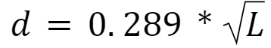

Group | Luminosity, L (QW) | Distance, d (Mpc)
A
B
C
D
E

Part C: Calculating redshift
Use the images provided for each cepheid and determine its redshift.
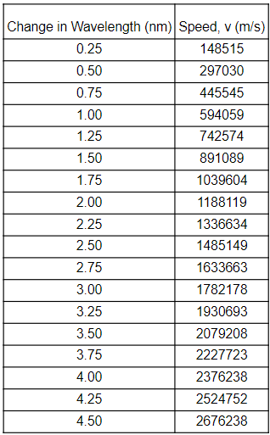
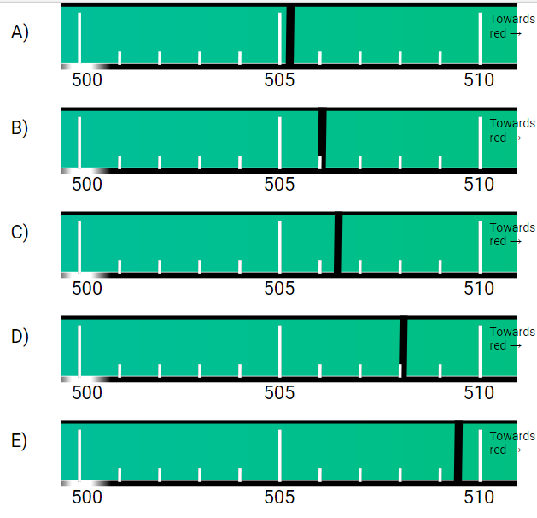
You will need to find its moving wavelength ($λ_{m}$) and then subtract its stationary wavelength ($λ_{s}$). Use the relationship:
$Δλ=λ_{m}-λ_{s}$
Once you find the shift ($Δλ$), find the speed in the chart below (use the value closest to what you found). Record this in the table provided.

Group | Stationary Wavelength, $λ_{s}$(nm) | Moving Wavelength, $λ_{m}$(nm) | Shift, $Δλ$ (nm) | Speed, v (m/s)
A
B
C
D
E

Part D: Expansion of the universe
Use your speed, v (from Part C) and distance, d (from Part B) to graph the relationship of the speed of the universe as it relates to the distance from the Earth.

The graph shows that the farther away you are the faster it is moving away from you. What is your conclusion?

